CS385 – CPU Project

Robert Rotaru, Bryan Bigelow, Anthony Cerritelli

# Progress Report 2

## Task Format

**Task**

* Subtask – [Contributor 1], [Contributor 2], etc.

## Tasks

**16-Bit Test Program**

* Assembly – Tony
* Binary – Tony

**Pipelining**

* IF – Tony
* ID – Tony
* EX – Tony

**Diagrams**

* Single-Cycle Path –
* Internals – Bryan

**Report** - Robert Rotaru, Bryan Bigelow, Anthony Cerritelli

## Diagrams

**Single-Cycle Datapath**

**Internals**

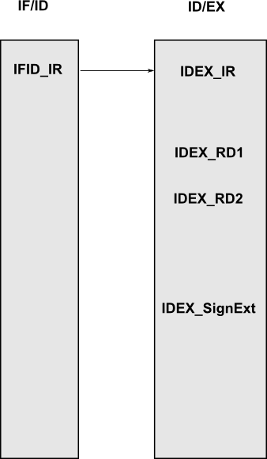

## Source Code

## Testing